Sample Application

Create an angularJS application that consumes a RESTful JSON api.

Requirement:

The rest api must be written in javaEE6 or javaEE7. It must demonstrate the following

* Stateless Enterprise java beans (EJB)
* Entity Bean
* Bean validation
* CDI
* JAX-RS using JSON

The front end must be Single Page Application written in AngularJS and UI Bootstrap (<https://angular-ui.github.io/bootstrap/>)

**Don’t worry about the UI and UX for the applications. I more interested in how you organise/structure your java code and how you structure the AngularJS application**

The application will have 3 Entities and the following relationship between the entities

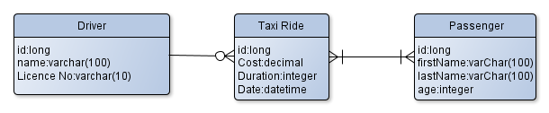

The Application will have the following pages:

* A page the list the drivers
* A page that add a driver
* A page that adds the Taxi Ride. On this page you have to select a driver, and add at least one new passenger or existing passengers from previous taxi rides.
* A report page that lists the taxi rides between two dates.